1. **INTRODUCTION** 
   1. Overview

An airplane crash analysis is a detailed investigation into the causes of

Aviation accident. The goal of an airplane crash analysis to identify any factors

that contributed to the accident, with the ultimate goal of improving safety and

preventing future accidents. The process of conducting an airplane crash

analysis typically involves the collection and analysis of a wide range of data,

including information about the aircraft and its systems, the operators, and any

other relevant factors. This data is typically collected from Kaggle. Once the

data has been collected, it is analysed through tableau, to identify any potential

causes of the accident. The results of an airplane crash analysis are typically

published in a report, which may include recommendations for improving

safety and preventing similar accidents in the future. These recommendations

may be implemented by the relevant authorities of industry organizations.

* 1. Purpose

This project is very useful to analyse the solution of the tragedy. This project

Results in various answers.

1. **Problem Definition &Design Thinking** 
   1. Empathy map

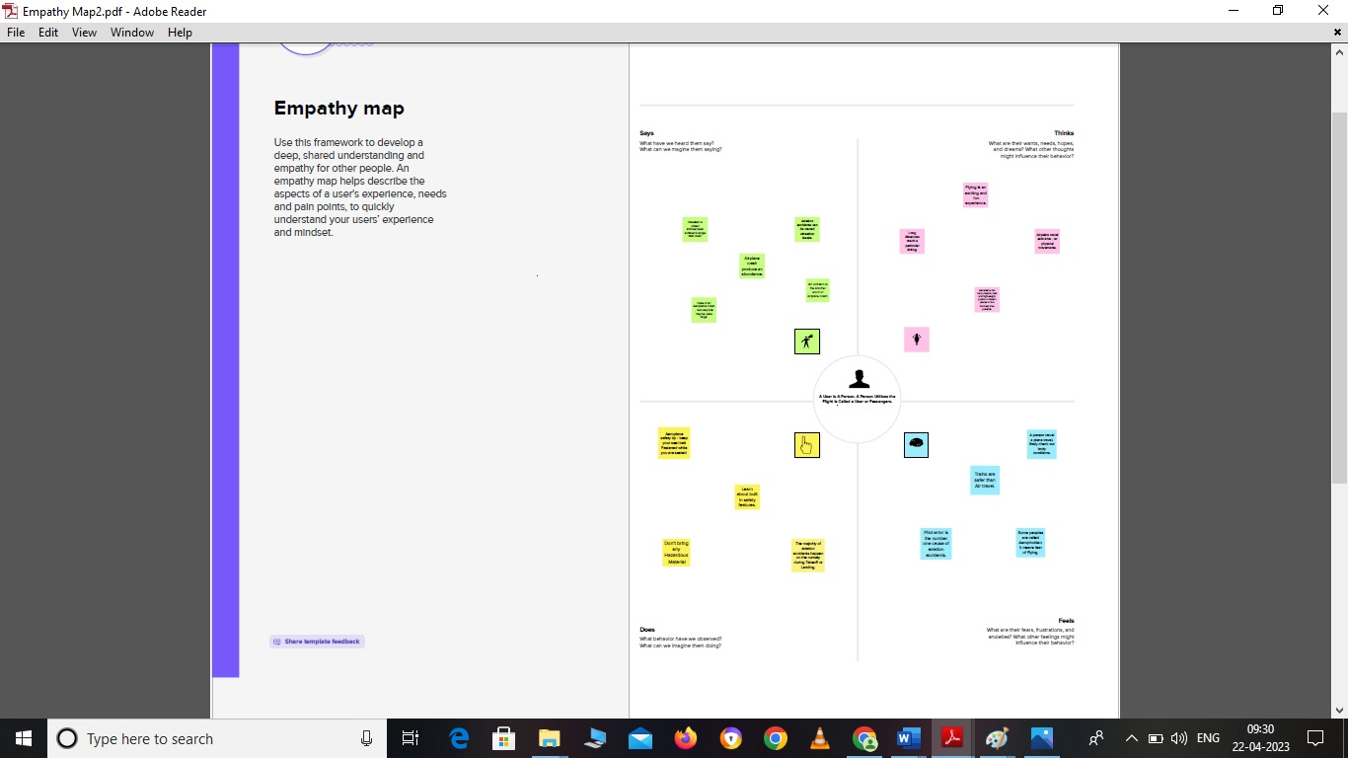

2.2Ideation & Brainstorming Map

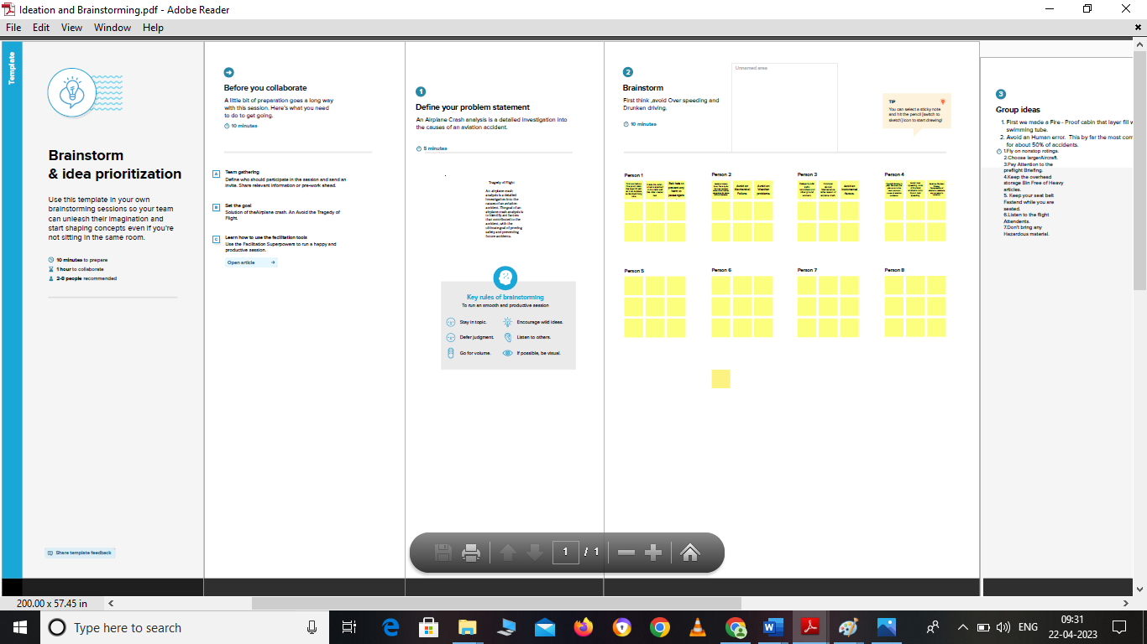

1. **Result**

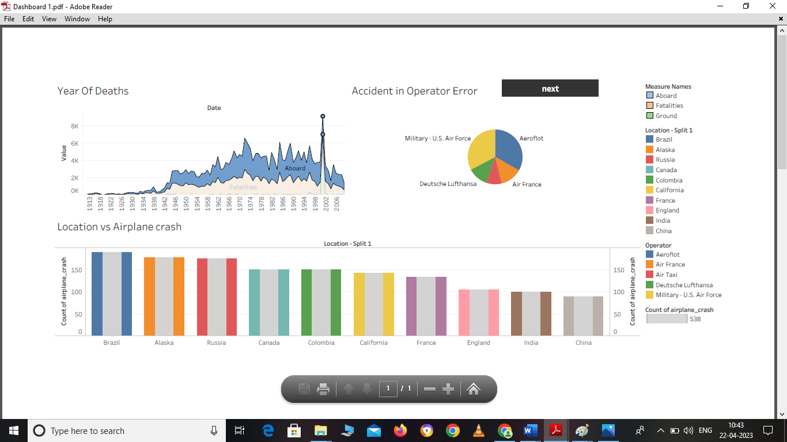

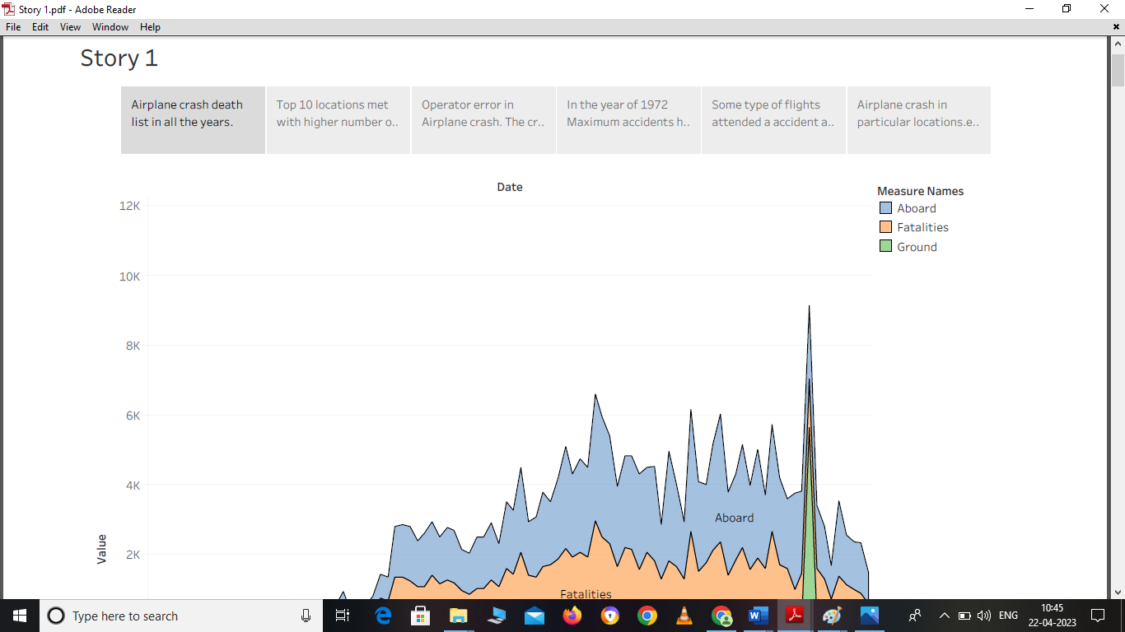

1. **Advantages & Disadvantages**

This project very use to learn about many things.

Ex; Tableau working, Dashboard making, webpage creation.

Sometimes Network error in the process of the project. It is only main reason for the disadvantages.

Some applications not acceptable for all the systems, it is other disadvantage.

1. **APPLICATIONS**

The areas of the solution:

Data Analytics

Tableau

Data collections

1. **CONCLUSION**

Airplane crash project is very innovative making myself. This project analytic in

Many ways. First collect all the dataset. Secondly, making worksheet and

Dashboard.

1. **FUTURE SCOPE**

Pilot error is the main reason of Airplane crash. So, first think avoiding over speed.